Joliet Central Girls Cross Country Gear Fundraiser
Athlete Name:_____________________________________________________________________________
All athletes are required to sell a minimum of 7 items. For every 10 items the athlete sells, they receive a team t-shirt free. Any athletes that does not sell the minimum number of 7 items, they will be responsible for the profit cost ($6.00) of the number of items they did not sell. For example, an athlete that doesn’t sell any items will owe the team $42.00.
Team T-Shirt | Team Hoodie | Water Bottle | Beanie Hat
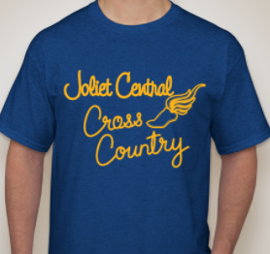 | 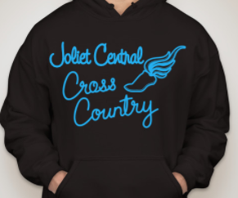 | 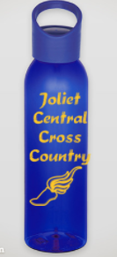 | 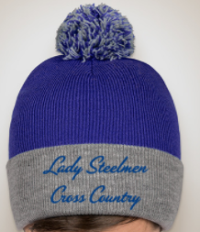
Available in Adult S- 4XL. (Additional cost for 2XL and above.) | Available in Youth XS-L, and Adult S- 5XL. (Additional cost for 2XL and above.) | One Size | One Size
Antique royal (heathered royal) with yellow-gold print. | Black hoodie with sky blue print. | Royal blue 22oz twist top water bottle with gold print. | Royal blue hat with steel grey band, and a royal blue and steel grey pom pom.
$15.00 | $25.00 | $10.00 | $20.00

Athlete Order Totals
Please total ALL of your sold items and money collected here. Write the total number of each item, as well as the total number per item, per size. All individual orders should be placed on the back of this sheet.
Team T-Shirt Total Number: ______________
S | M | L | XL | 2XL | 3XL | 4XL

Team Hoodie Total Number: ______________
YXS | YS | YM | YL | S | M | L | XL | 2XL | 3XL | 4XL | 5XL

Water Bottle Total Number: ______________ Beanie Hat Total Number: ______________

Total Number of Items: ______________
Total Amount of Money Collected: ______________
(*note that change will NOT be provided. Athletes are expected to turn in the exact dollar amount!)
Athlete Name:___________________________________________________________________
Individual Orders
Name |  |  | Contact (Room #, email, phone, etc)
# Water Bottles |  |  | # Beanie Hats
# Team T-Shirts | S M L XL 2XL (+$3) 3XL (+$4) 4XL (+$5)
# Team Hoodies | YXS YS YM YL S M  L XL 2XL (+$3) 3XL (+$4) 4XL (+$5) 5XL (+$6)
Total Number of Items |  | Total Cost

Name |  |  | Contact (Room #, email, phone, etc)
# Water Bottles |  |  | # Beanie Hats
# Team T-Shirts | S M L XL 2XL (+$3) 3XL (+$4) 4XL (+$5)
# Team Hoodies | YXS YS YM YL S M  L XL 2XL (+$3) 3XL (+$4) 4XL (+$5) 5XL (+$6)
Total Number of Items |  | Total Cost

